Name-Ujjawal Mandhani
Batch-F6
Enroll No.-9918103237
ISL Lab Test 2 SET A

Question 1:

#include <bits/stdc++.h>
using namespace std;

int main()
{
string msg = "KeEp smiLinG, beCause liFe is a beAutiful tHing";
int mic = -1;
string cipher = "";
for (int i = 0; i < msg.length(); i++)
{
if (msg[i] == ' ')
continue;
mic++;
if (msg[i] >= 65 && msg[i] <= 90)
{
cipher += char(int(65 + (msg[i] - 3) % 26)); //this is error try correcting logic
}
else if (mic % 5 == 0)
{
cipher += msg[i];
}
}
cout << cipher.c_str() << endl;
return 0;
}
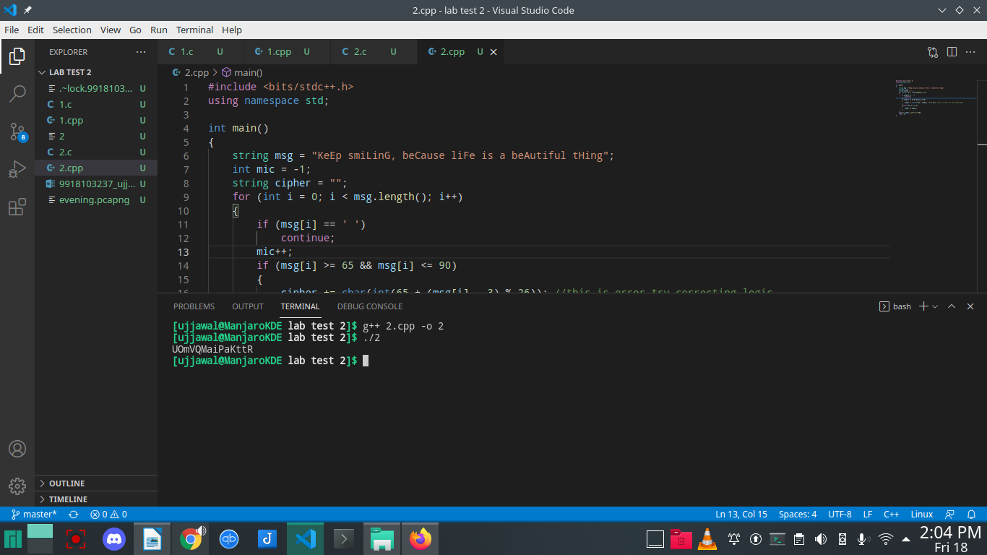

Question 2:

(a)

the response time of HTTP GET menthod for packet 4 is 0.408420 seconds

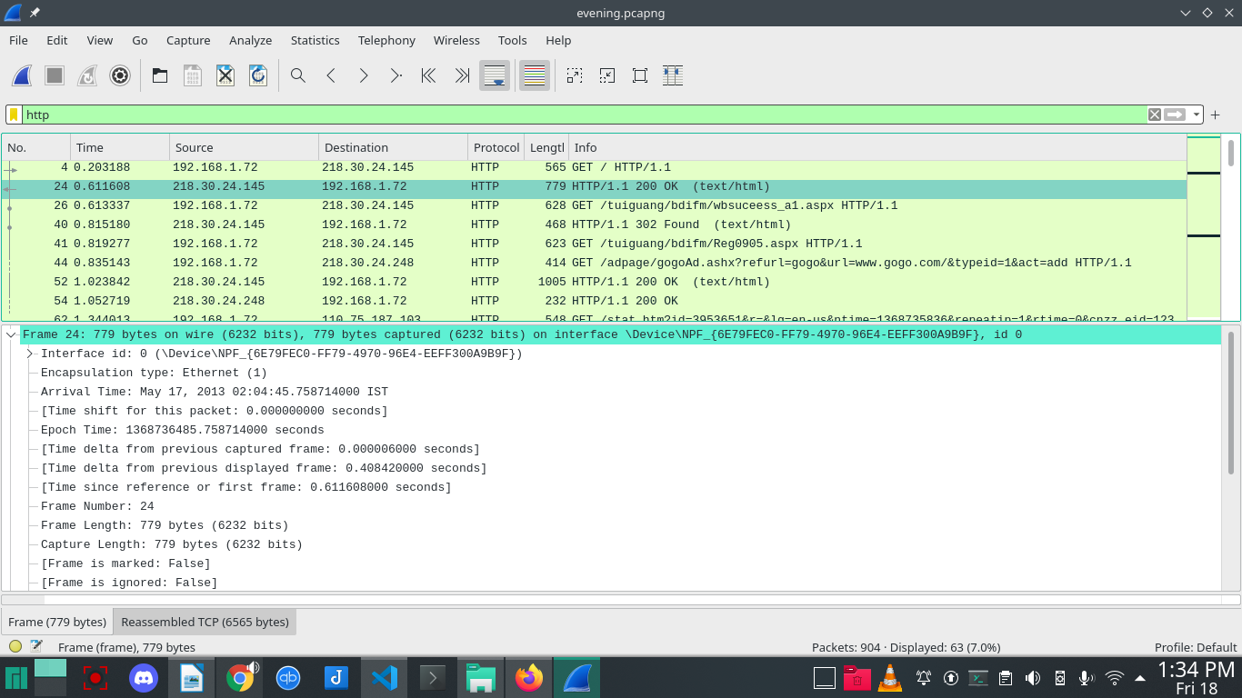

(b)

Total number of outputs =101

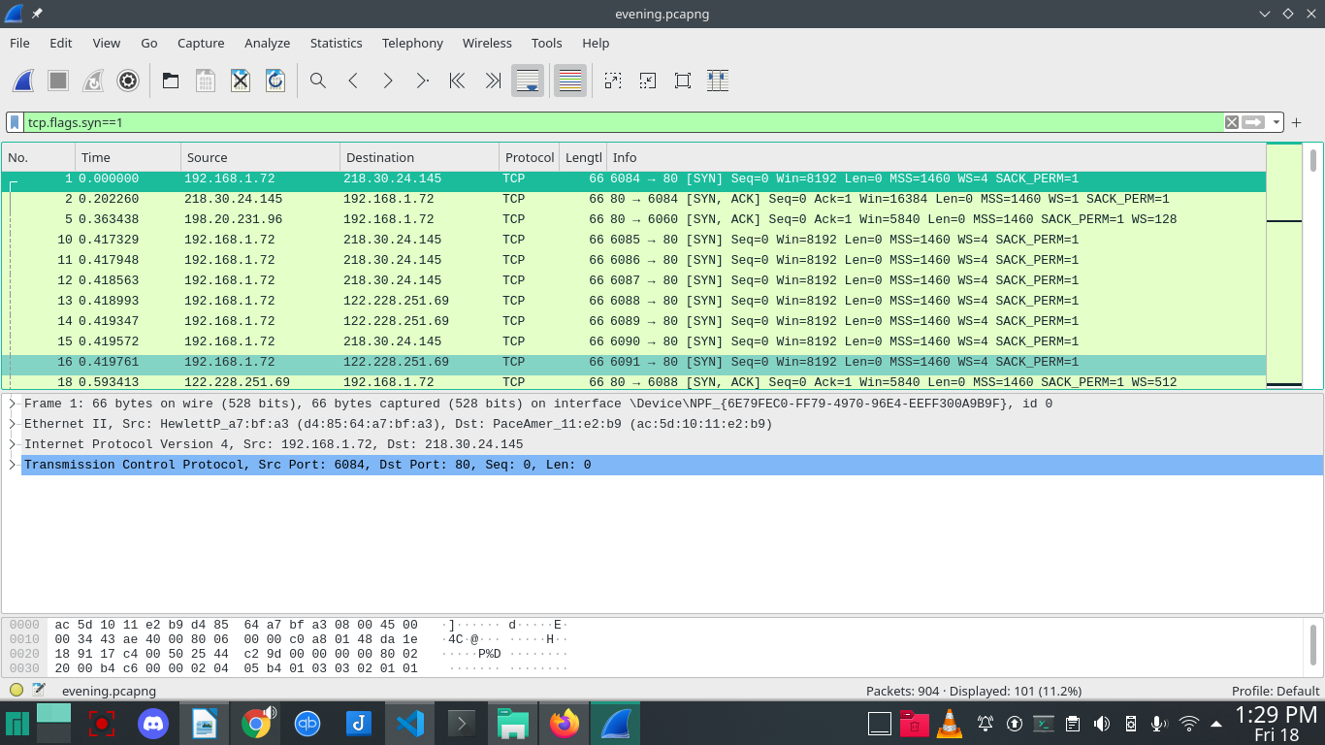

(c)

packet number is 805

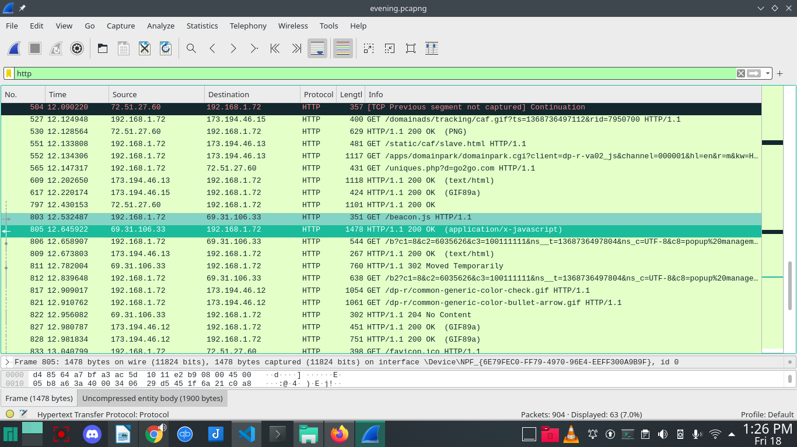

(d)

total time = 13.040074000 seconds

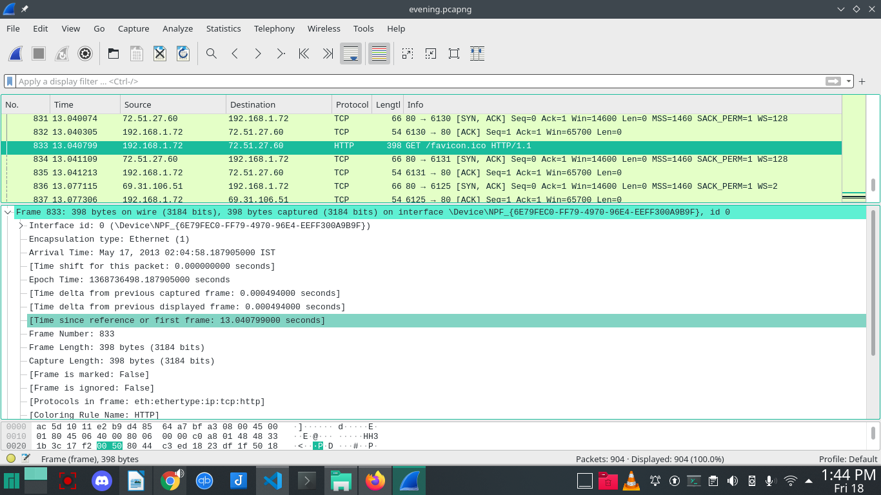
(e)

The Previous Frame is 48

